Transcript: Webinar - COVID-19 challenges and solutions 2. Understanding hospital onset and hospital-acquired COVID-19 | 20 May 2020

Watch the webinar
During this webinar our audience submitted their COVID-19 IPC questions to our expert panel.
Panel members:
- Dr Eimear Brannigan, Consultant in Infectious Diseases, Imperial College Healthcare NHS Trust
- Professor Alison Holmes, Professor of Infectious Diseases, Imperial College London
- Dr Lisa Ritchie, Head of Infection Prevention and Control, NHS England and NHS Improvement
- Dr Walter Zingg, Head Consultant in Infection Prevention and Control, University of Geneva Hospitals, Geneva, Switzerland

Chair: Dr James Price, Consultant in Infection Prevention and Control and Antimicrobial Stewardship, Imperial College Healthcare NHS Trust

Disclaimer
The HIS webinars may contain expert opinions and preliminary reports of work that have not been certified by peer review. They should not be relied on to direct clinical practice or health-related behaviour and should not be reported as established information without the consent of the panel members.

Uncertified transcript
The following transcript of this HIS webinar, or any portion thereof, is being delivered UNEDITED and UNCERTIFIED by the Healthcare Infection Society and Panel Members, and was created using artificial intelligence software. The reader agrees not to disclose or copy this uncertified and unedited transcript in any form (written or electronic) to anyone. This is an unofficial transcript, which should NOT be relied upon for purposes of verbatim. This transcript has not been checked, proofread, or corrected. It is a draft transcript, NOT a certified transcript. As such, it may contain computer-generated mistranslations, resulting in inaccurate or nonsensical word combinations.

00:00 James Price
Good evening, everyone. Thank you for joining us on our second in the series of webinars on COVID challenges and solutions. These are hosted by the Healthcare Infection Society. Today's webinar is going to focus on understanding hospital onset and hospital acquired infection. The webinar is going to be recorded and be available afterwards for anyone that couldn't make it so please feel free to pass on the word. My name is James price and as well as being an infection control doctor in Imperial College. I sit on his Council, and I'm the chair of the HIS Professional Development Committee.
We have a fantastic panel of experts here to share their thoughts on a broad range of topics all things hospital onset COVID related. So I'm going to ask them to introduce themselves. So if we could start over to Allison Holmes.

0:51 Alison Holmes
Hello everybody, I'm Alison Holmes I'm sitting in an office in West London at the moment. I work at Imperial College and Imperial College Healthcare NHS Trust. Nice to see you.

1:05 James Price
Thanks Alison, welcome. Moving on we have Walter Zingg,

1:09 Walter Zingg
Yes. Hello everybody, my name is Walter Zingg, and I work at the University Hospitals of Geneva. I'm a head consultant in infection prevention and control, and my background is infectious diseases and paediatrics.

1:24 James Price
Thanks Walter. We have by telephone Lisa Ritchie.

1:32 Lisa Ritchie
Good evening, everyone. I'm sorry that I'm on the phone, in a car, and it's a bit of infection prevention control for NHS England and improvement.

1: 48 James Price
Thanks Lisa no worries at all. We all know what technology is like in these days of COVID. And last but by no means least, we have Eimear Brannigan.

1:53 Eimear Brannigan
I'm an infectious diseases doctor and the deputy director of infection control at Imperial NHS Trust.

2:02 James Price
Thank you and thanks for everybody for volunteering their time, maybe with only a little bit of arm twisting required. So, one thing I wanted to highlight before we start the webinar is as everyone is very aware, COVID is an evolving field that we are all dealing with. New information is being presented to us all the time. A particular case in point is, in the last half an hour there's been a national IPC webinar hosted by NHS and NHSI. I wanted to emphasize that our panelists have been pairing for this webinar so haven't had time to fully absorb what has happened, and all the new information is potentially available, but I think this really highlights exactly what's going on and what we're having to respond to. So can everyone bear this in mind as we take the webinar forward.
Before this webinar we asked you to submit questions to put to the panel, and we selected eight of the most popular questions to discuss during the first 40 minutes. During the last 15 minutes we will aim to answer live questions which you're going to submit via Slido – the app we're going to use. Also during the event you're going to be able to vote for our live polls. So for anyone who hasn't done it yet, please do download the Slido app. And when you get onto that if you enter #HIS, that will put you through to the live streaming and there should be a QR code which may pop up on your screen shortly. So in order to help us get familiar with this we've prepared a warm-up poll to get familiar. And so hopefully that's going to come up on your screens now.
Great.
So the first poll question we have is “How often have you identified nosocomial acquired infection of COVID in your organization? “. And you can see the four different points down there it's going to be interesting to gauge what people have found on this.
Let's have a look. If everyone is happy to submit their answers.
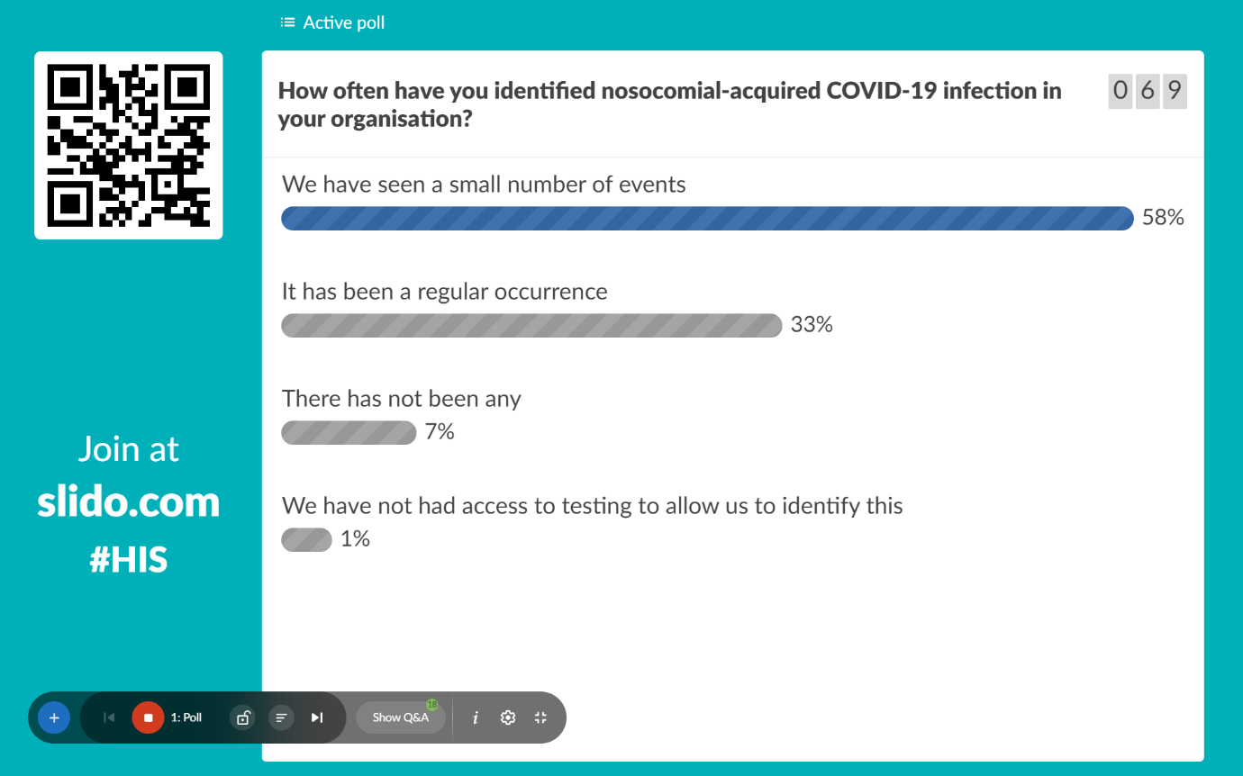
Okay, I can't see the answers, but I don't know if anyone else can? Fine let's make an assumption that there's been a wide variety of responses across the country. So, the first technical flaw but not a problem. Let's move on to our first question.
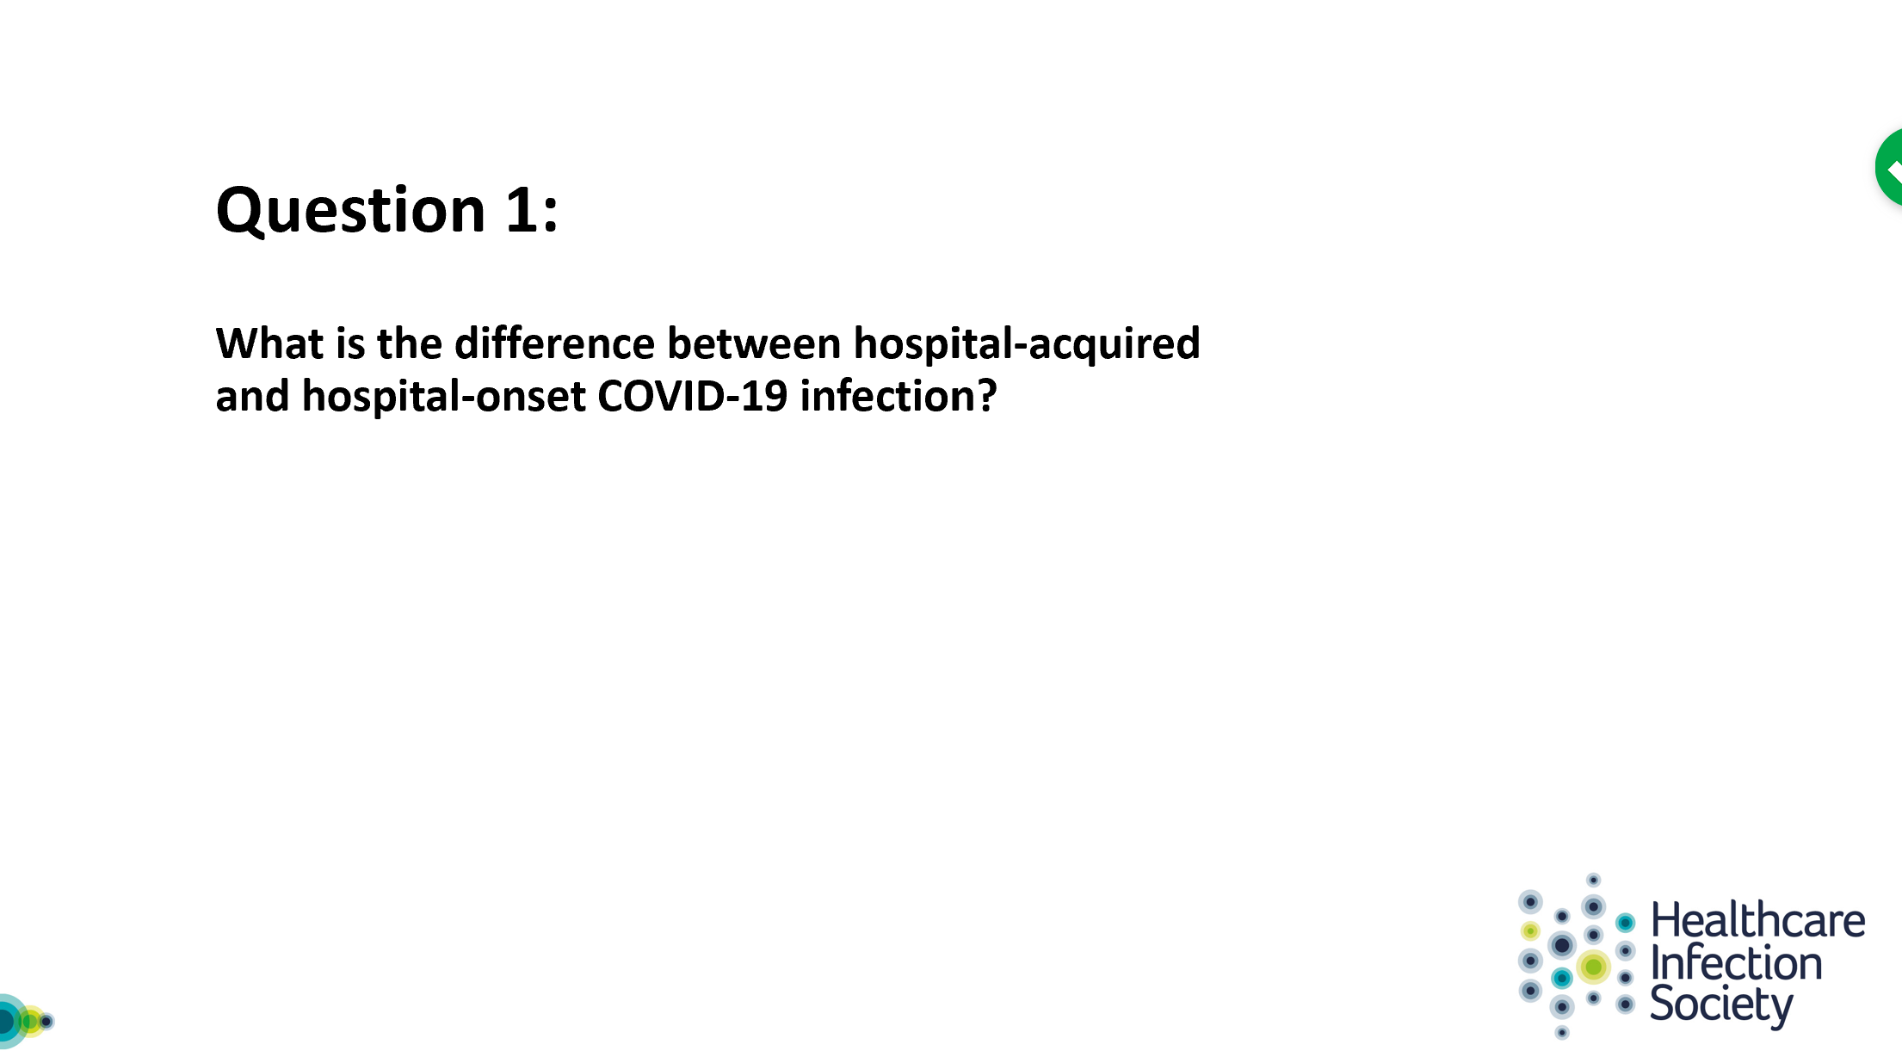

And I'm going to ask Allison Holmes to take the lead on this please. Thanks Alison.

4:53 Alison Holmes
So, thank you, James. And so, as you said there's quite a lot of national discussion about this but I'm going to present this from our local experience and our efforts to develop surveillance. So at the beginning of March, we really felt that it was appropriate that the infection prevention and control service developed a surveillance system to capture potential nosocomial in infection covert in COVID. We thought that that was a really important thing to do and to have it is almost in real time as possible. And we went down the avenue of thinking about hospitals onset COVID infections (HOCIs) rather than hospital acquired COVID infections (HACI). And I want to thank James for the naming. But the reason for that was the issues about being pragmatic. So there were no definitions, at that time, and it was critical if you're going to look for nosocomial infection you want to capture as much as possible, and not be definitive about where it was actually acquired. So it was important that it was broad brush, and it was hospital onset so that we could, we could capture any potential case that was test positive during an admission, and particularly because you need to recognize the wide variation in the wide variation in the incubation period. So you need something that you can investigate further. So hospital onset rather than hospital acquired we thought was extremely important. It sends a signal and then you can investigate further, and then you've got the opportunity to capture as much data as possible and learn from that and improve things. So, as I said at that time there were no standard definitions we developed a surveillance system. And we, we have kind of two pragmatic approaches we called a HOCI - a definitive HOCI - if it was after 14 days of admission and the patient was found to be positive, and that they were admitted without any COVID-like symptoms.

And then, a probable one, if the patient again didn't have symptoms on admission, and it was between seven and 14 days. I realise that there's going to be further decision making on definitions, but that's what we used as a Trust. And it was important - this was a signal for further investigation. So, I also think it was important that they were hospital onset to enable us to work with all the frontline staff - to say we just need to investigate this a bit further and we need to learn more. And we're also delighted that we're going to be able to do some genomics work as well. To find out a little bit more about our transmission, but that was the reason we went with onset, rather than acquired and thought that that was quite important.

8:23 James Price
Great, thank you. Alison, I just want to open this up to the other panel members and see if they have any comments, suggestions about that.

8:32 Eimear Brannigan
I suppose to say that that is indeed where we got to, and I suppose the other thing we've begun to learn about is the logistical challenges of how to actually do that. And what that means, because as Alison has alluded to, and there is a definition that involves a bit of symptom gathering at the front door, and a definition that involves a test. Obviously a test is a hard and fast thing that you can you can look, and the symptoms are a bit more subjective. So there are challenges, about how to apply a definition, a definition of this sort, as we know for many other surveillance definitions when it comes to infection.

9:16 Walter Zingg
Well it's interesting. I think in Geneva, we, we went we took another path actually. So, when I'm confronted with HOCI and HACI, I would have expected more like something beyond 48 hours, versus more longer incubation period, taking into account. So, I'm on the board and advisory board, have a study going on in the UK where actually they use the beyond 48 hour rule. But they do whole genome sequencing and I think there it makes sense because probably this will give them enough information. Then in the long run, to conclude on this and what could be a relevant, time, time period to take into account.

10:18 Alison Holmes
So, I just want to get back to you there because we what we were saying was after 14, it's a definite but between 7 and 14, it's probable but that we are capturing all of that data. I also think that's really important when you're working with your clinical staff that that you can understand that there may be, you know, broad variety and incubation. But clearly, I was saying that we capture any test that's positive during admission, and it enables us to investigate it a bit more. And the other thing I think we should stress is this actually becomes more and more important, as we start opening our doors and having more and more COVID naive patients. And we saw this as a important aspect of kind of, you know, restoring our healthcare as well, and part of recovery, that this should be kind of embedded in what can we do to make sure that patients and staff are safe. No, absolutely Walter - it would be captured much earlier on, but definite was after 14 days, and the probable was the seven to 14, and possible or to be investigated further was the earlier onset, because they so hard with the incubation period, particularly if they haven't come in with come in with symptoms.

11:50 Walter Zingg
Yeah, I mean, I mean in Geneva we're even more pragmatic than that, So basically we just said “okay so what is the median incubation time? It's five to six days - so we went just for five days so everything that is beyond five days for us is potential.

12:08 James Price
Great, thank you all. In the interest of time to get to the questions, let's move on to the next question and we have our second poll question. I've been told that the Gremlins have been removed. And so our second poll question for the audience is to comment on is “Do you routinely screen asymptomatic healthcare workers for COVID-19?”
Let's just give a couple of seconds to see what people's responses are. I think we're starting to get an idea.
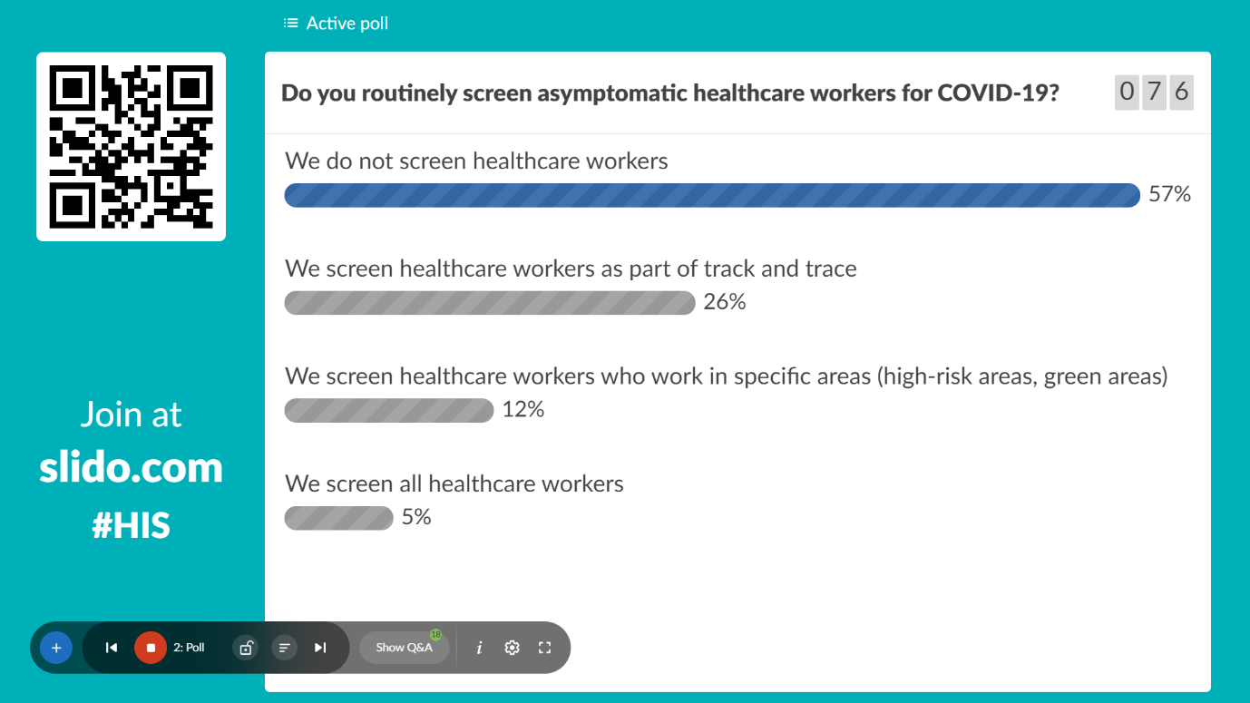
Okay, it's just how wide the differences across the country. Fantastic. Well, let's move on. So, we have our next question which has been submitted by the audience.

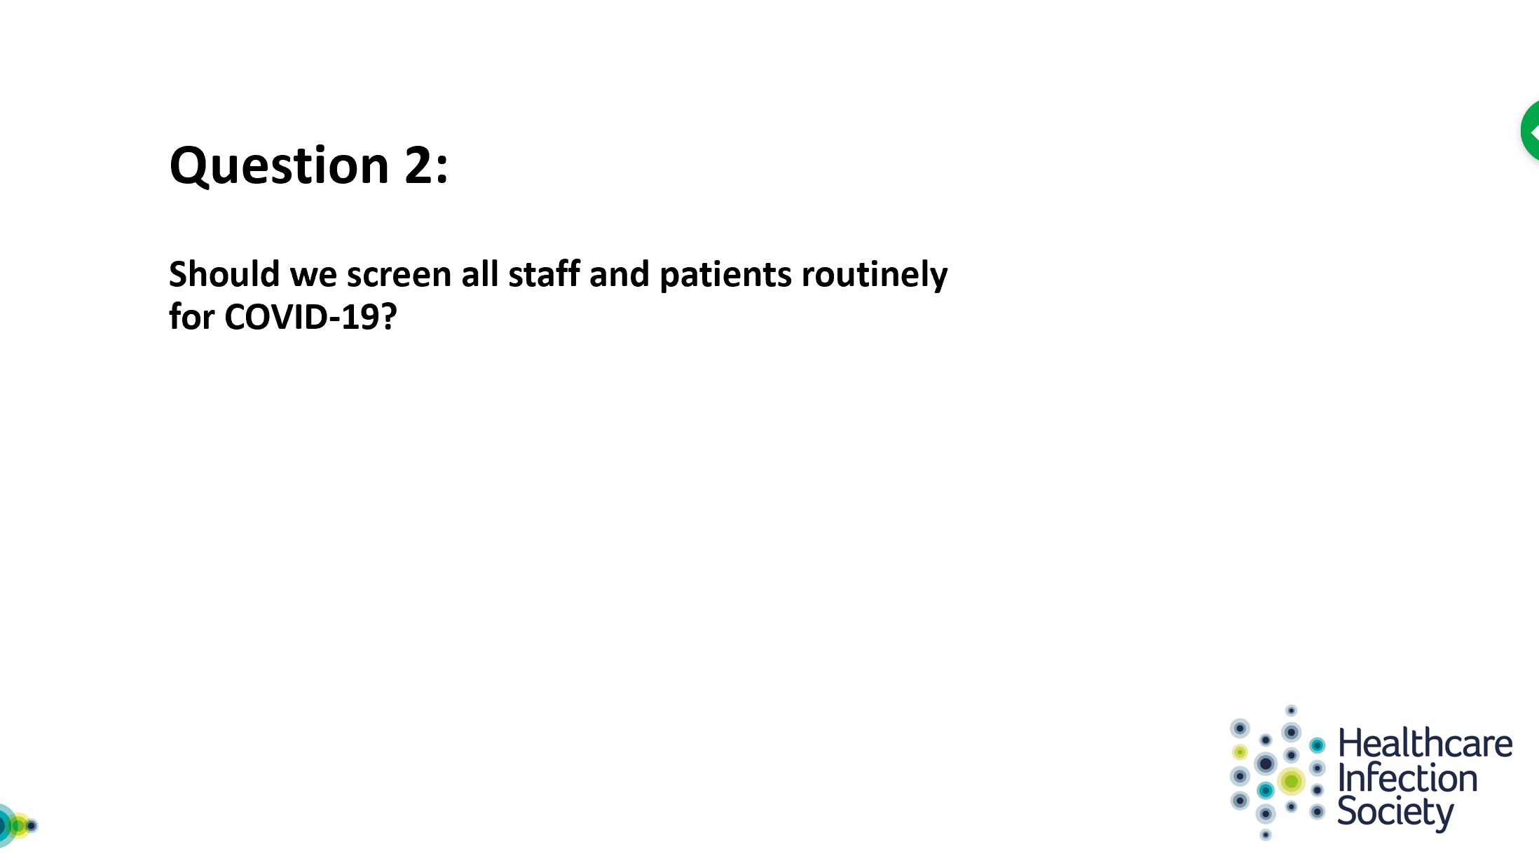
And I would like to ask Eimear Branigan to take this on please.

13:31 Eimear Brannigan
So in thinking about this, I've been thinking about virus detection. So, testing for virus detection. I won't consider serological testing at all, although that is becoming a point to consider.
And in terms of screening, again, just to be clear, I've considered that to some screening means checking for symptoms and asking for symptoms, or some sort of detail about and exposure or history. But what I’m talking about is actually swapping our testing for the presence of virus so just to make that clear as I, as I talk through this. And, and we could come back to some of that because I think screening in terms of not actually swabbing for the virus but thinking about symptoms, and temperature for example, may I may also have a role. But what I'm just going to talk about was just testing for the virus.
As the recommendations come out about how to get back to and doing a bit more and more normal clinical practice, and this is thinking about England particular, and we are seeing the need for testing for staff and patients come in as to consider, or as needing to have a robust program about this. And I suppose what we're seeing is that the recommendations are for robust testing for staff. And when we're thinking about a program or a program of care that is considered in the gold end of delivery care. And of course, when we're thinking about screening or looking for any of these conditions, we're thinking about doing it for a purpose which is usually to have an intervention. And in this case of course that means the isolation or the segregation away from others in order to prevent transmission. So I suppose that's the thinking behind why one might do this. And the pros for testing widely, are of course, that this permits early detection or detection of early cases. And it affords this opportunity for intervention. Prior to someone becoming an infection risk for other parties. On the detractors I suppose, point out issues about testing. And in terms of interpretation of a test. In light of falling prevalence, in terms of what is a positive test mean in an asymptomatic individual, and risks of false positives. And of course the false negatives. And these are issues that detract in general from thinking about testing more widely.
However, it seems to be increasingly becoming accepted - or perhaps it's in the little bubble in which I live and work - that to protect our ’COVID protected pathways’ – the terminology, we're beginning to get familiar with, we're going to need to have robust testing programs. I'm going to say that for our patients and for our staff.
And so that is not whether we should, but it looks like that is the direction of travel. And so again, the questions that arise from that is, how do you achieve that for a patient? And again, we are seeing increasingly that for elective - or COVID protective pathways - testing prior to admission to a so called ‘Green pathway’ is becoming a recommendation. Once the availability of perhaps rapid point of care testing increases, we can see that a role for that would increasingly become relevant, as people arrive in, in the physical environment for their care. This is less clear for so called ‘Blue’ or ‘COVID risk managed pathways’ where, again, rapidity of tests perhaps might be valuable. And then the additional question is whether to serially test patients. So patients who are in for just a short period of time perhaps there is no additional benefit once you've identified whether they're positive or negative at the front door. And, but perhaps patients are in for longer we would like to detect if they're on a Green pathway - whether they might have acquired it in the organization - or been incubating as they’ve arrived. And also if had been there for longer than that, and on other pathways Are there risks to others? Have they acquired in the organization themselves? And then we get to the thorny issue of staff, and how to do this and staff? Again, would this be temperature checking only? And we are back to that term of screening, or would this be actually testing and how would that be done? And at what intervals would it be done if you're working in a Green or COVID protected pathway. Would it be useful or wise to do this daily? At seven day intervals? And, how to deliver that and achieve that with the appropriate support for staff, and with whatever the outcome of that testing is. So those are some initial thoughts on that.

19:21 James Price
Thanks Eimear. Really insightful. I’ll briefly just open this up to the panel. Do does the panel have any comments?

19:37 Walter Zingg
I can say a little bit about what we're doing here actually. First of all when we talk about healthcare workers, during the hot phase of the outbreak because I mean recently if you if you saw the numbers of Switzerland, we barely have new cases per day. But during the hot phase, in the beginning of course we had limited testing so we encouraged healthcare workers not to take a test and just use the mask. Then we move to, if you if you have symptoms, take a test. And this is actually where we still are. We only applied a broad testing for all healthcare workers in situations of outbreaks in non-COVID wards, where we just needed this information to come to paint the outbreak, but this was actually only the case in one particular outbreak.
And when it comes to patients, there also we had a dramatic shift from the beginning where we tested only patients with symptoms. Then we will talk about this bit later, when I talk about our experience, tell you a bit the story here in Geneva. Now we have a testing for all patients entering the hospital, not an outpatient clinics but but for inpatients - all inpatients get a test right now. I think it is, it is a challenge because we know we started to do some serology in healthcare workers, by the way, but this is more like an ongoing project so I do not officially know the results because we do retest healthcare workers, every three weeks with the idea to see whether t we have an increased seral prevalence. But the seral prevalence in the population is low. So basically, we know already that we test, too many patients and, indeed, we have too many negative tests for now so associate. It’s fine we are now in the transition phase of the confinement. But at some point I'm sure that we have to reconsider this practice.

22:05 James Price
Thanks Walter. So in the interest of time, let's move on. I'm going to move straight on to our next audience-lead question.

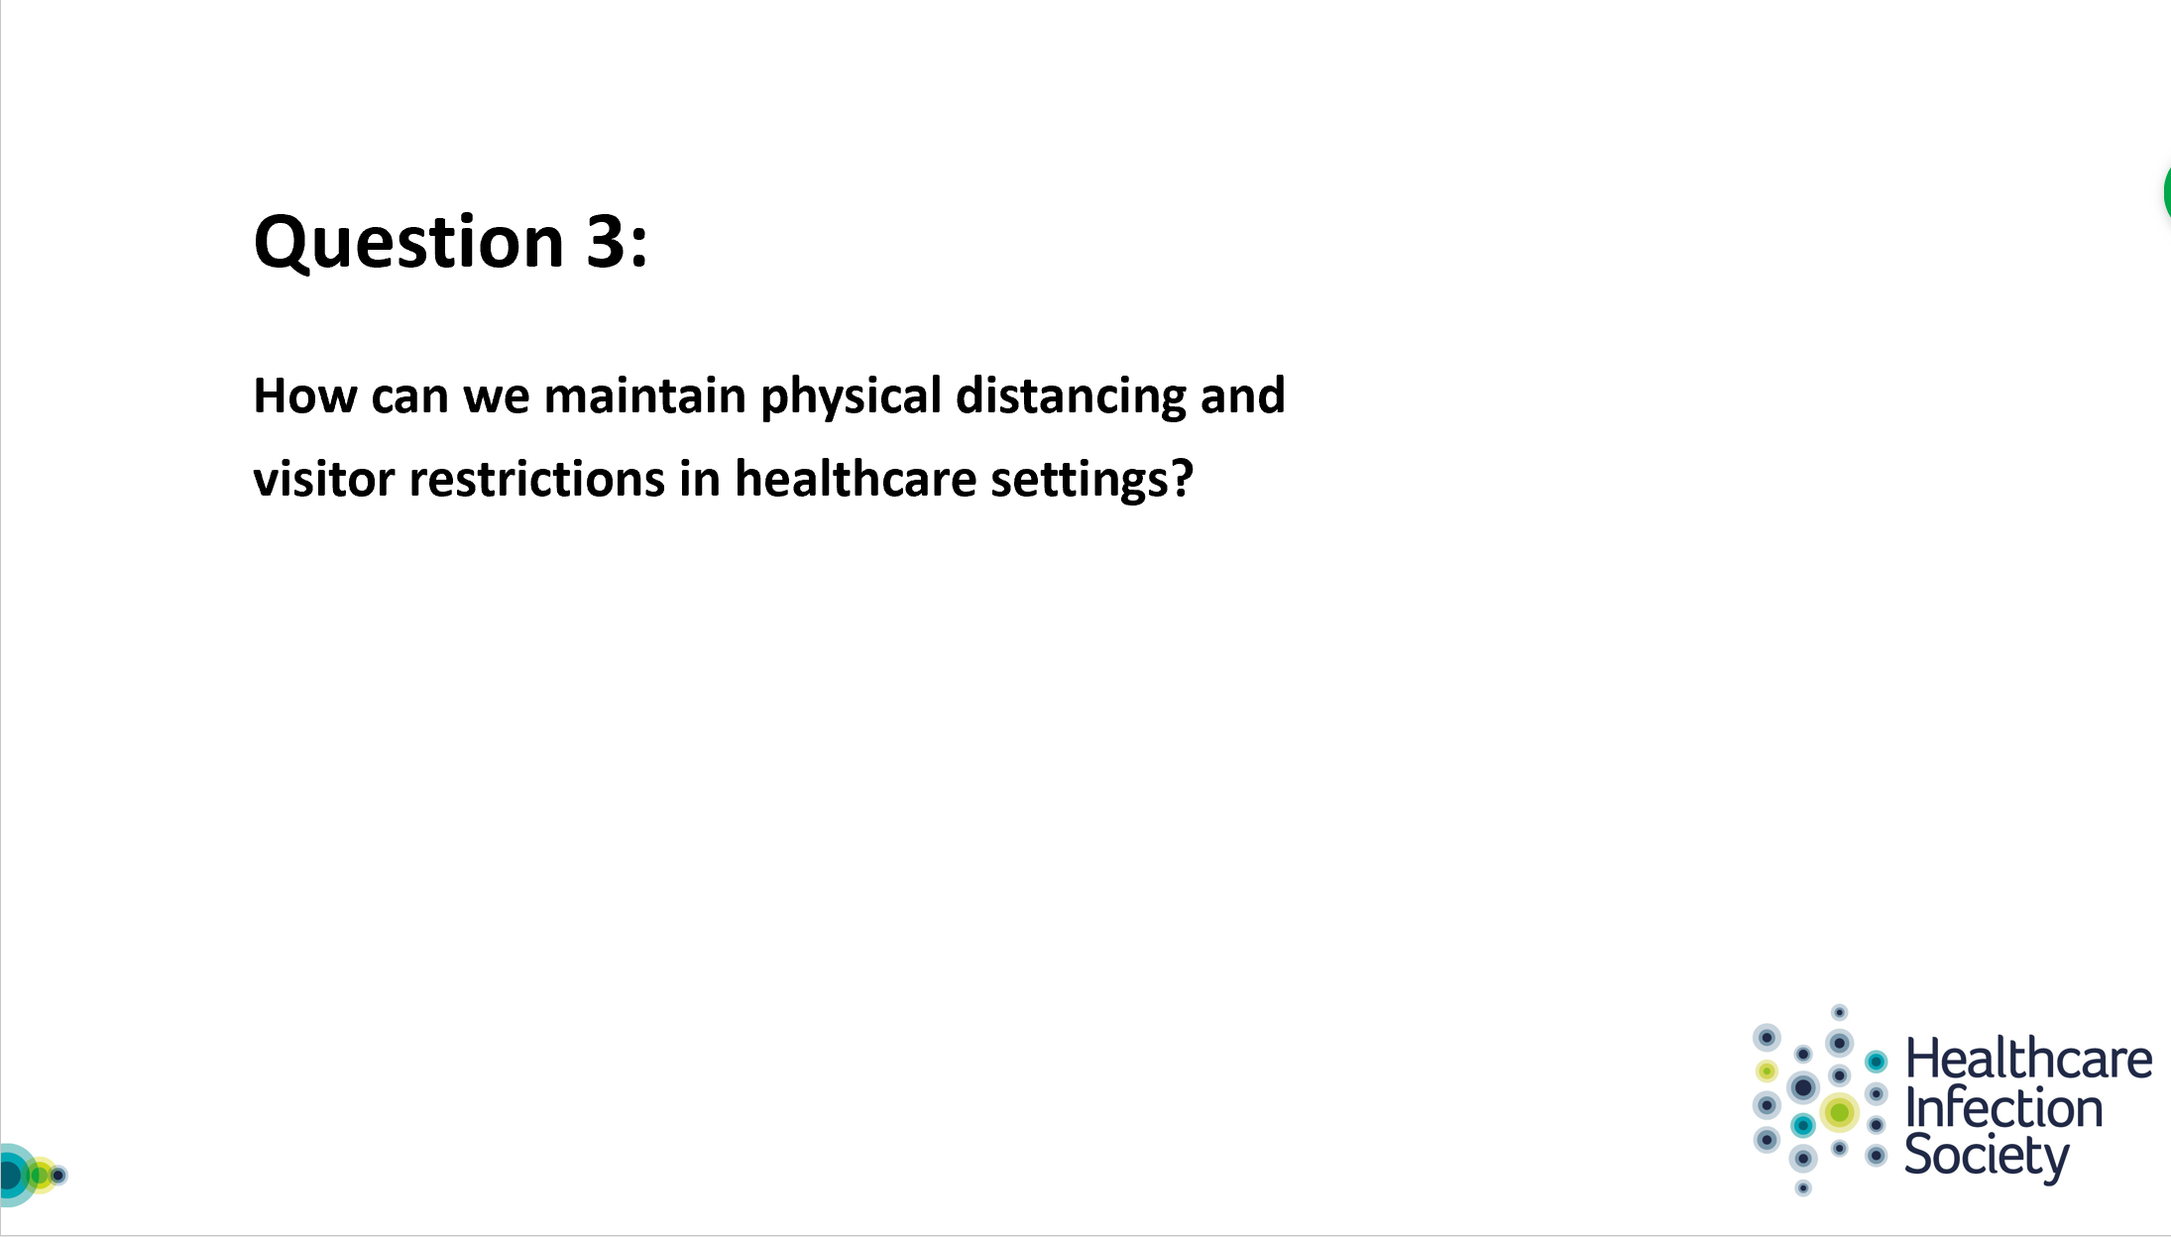
I'm going to ask Lisa Ritchie to take this on, please.

22:30 Lisa Ritchie
Okay. Hi, James. We know that SARS-Cov-2 the virus that causes COVID-19, spreads primarily through respiratory droplets. Produced by infected people when they cough, sneeze, talk or just when they simply breathe out, and the droplets are breathed in by others. And I was interested just to read that loud talking has apparently been shown to generate many more droplets that's been quieter talking. But anyway, this is why physical distance and so important. And we've all know where that the 6ft/two meter rule for preventing transmission of these infectious droplets. I'm probably not going to tell you anything that you don't already know, and however in addressing the question I would say that physical distancing has been achieved in most areas of healthcare sectors to date. As service delivery, in many areas of healthcare have been suspended and or alternative arrangements to service provision have been made.
For example in primary care settings, and an outpatient and some daycare services, how patient care assessment is made and how are is managed have changed. And I think it's changed in time. So where many patients would have congregated together in waiting rooms, instead of that specific time slots have now been given to space out patients for that appointment. And we've also seen a change in place. When alternatives such as telephone medical appointments are being maximised, and therefore I think the ability to adopt these measures have really helped to maintain physical distance in between patients and healthcare workers, and to a good extent between healthcare workers themselves.
I think, in addition to that areas such as emergency departments and triage areas, again within outpatient departments the promotion, and maintenance of social and physical distance in between patients, primarily I think has been supported by a number of examples. We have signage to encourage social distancing and behaviour. And we've got 2m spacing marked out on floors, we see waiting area chairs and assessment trolleys being spaced at least two meters apart. And the use of other physical barriers between patients and between healthcare workers that have been put in place.
And then, I think the other thing is about minimizing the density of people in all these areas I think also has supported physical distancing. And certainly the restriction of accompanying individuals, and with patient respective to an essential person such as a parent and other paediatric patients. And when I had recent experience and personally myself having to sit in my car in a hospital carpark for photos was waiting on my son, albeit he's 20 years old and get through accident and emergency.
And, and then in the inpatient environment, and the physical distance and is currently being maintained and by keeping the space in between patient beds to the 2m between, and, in some cases, to affect that or even to extend that - removing beds from key areas, and to achieve that to a distance. And then, the use of privacy curtains and screens between beds and cohort areas, and have been put in use to minimize the opportunities for close patient contact.
Again restrictions in place for visitors. Turning to the visitor question, on maintaining visitor restrictions. I think we have all seen the increase in the use mobile communication devices in hospitals by patients and relatives, during the three four months. And I think I'd be really interested to get feedback from patients and from their families and, if anyone else on the panel have any feedback about the experience of families and patients aside from those relatives of those receiving end of life care. I think that feedback and should help inform any future decision making on hospital.
So, I've focused a bit on the patient's physical distance and kind of turning to the social distance and a physical distance in between our healthcare staff as a group. I think from what I hear, and it's probably a greater challenge that lies within the healthcare setting, and probably more so within our hospital settings.
Whilst there are recommendations for maintaining physical distance in clinical areas and such measures have included, and some feedback I've received about reviewing board practices to minimize close contact between groups of staff over a long period. Avoiding congregation at central nursing stations for example, restricting the number of staff and ward rounds. Carrying out handover sessions in a setting where there's a space for social distancing. And then external to those clinical areas, the use of video meetings as a real alternative to internal as well as external facing meetings.
And then in the open plan office areas, and I've seen fixed barriers and spaced out chairs being used in order that the workstations are much further apart. And then another recommendation has been made and guidance has considered is staggering staff breaks to limit the number of healthcare workers in one specific area at a time. And although I did have one colleague tell me that after going in and reorganizing the chairs and their staff rooms to the socially accepted distance, she went back to find that the staff had moved all the chairs back around a small dining table in the room.
I think another nice example that I’ve heard is a roving champion. So this is where one hospital has got volunteer observers, reminding staff in corridors and lifts and other public places to maintain physical distances. I think the adherence of staff to social distancing, particularly when providing or not providing direct patient care - possibly the main challenge, and within a limited public in an around healthcare setting there's some interesting anecdotes, and I'm sure we've all heard. And where healthcare staff are I think conforming to the social distancing measures when they're out with the work environment. They think they have a different perspective in their place of work when with their colleagues. So, I suppose for me it's back to that old chestnut of the culture. And so it's one thing to know what we should be doing. And it's another thing to do it thoroughly and to do it reliably.
I think in many areas of healthcare physical distancing can, and should, be maintained by the changes that have been made to work activity, and patient assessment and management that have led to less people being around in one area in given time. Switching to telemedicine, and the way that healthcare systems have adapted to the social distancing requirements. Meaning, the way in which services are delivered in primary care. Patients for example, may need to change for a long while or even forever. If it has worked well now, why would we go back to previous ways of working? I think suddenly the use of screens and other physical barriers, spacing marked out on floors, and signage to encourage behaviours that support social distancing is critical. And I do think it can and should be continued. And I think these measures in addition, obviously to all other infection prevention and control measures, are all important to maintain as we head into a restorative phase in this pandemic. With the potential for further pandemic wave in a few months time, and also heading into that winter bug season that we have of course influenza.
So again I think physical distancing and an avoidance of lots of numbers of people or groups in hospitals, including our healthcare workers, will be required to minimize risk of virus transmission be it COVID-19 or influenza.. I think limiting the visitors and consultation by phone or video should be practiced wherever possible going forward. Thank you.
31:12 James Price
Thanks Lisa that was really, really insightful. In order to be able to get some of the live questions at the end I'm going to move, move on to our next question but thanks a lot. So I think we have our third poll question coming up now. Perfect. So the question is - if everyone gets their slider apps ready.
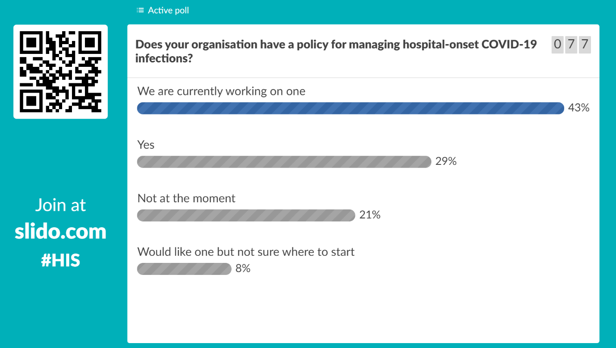
Again – a mixed bag we are seeing across the country. Well, if we move on to our next question.
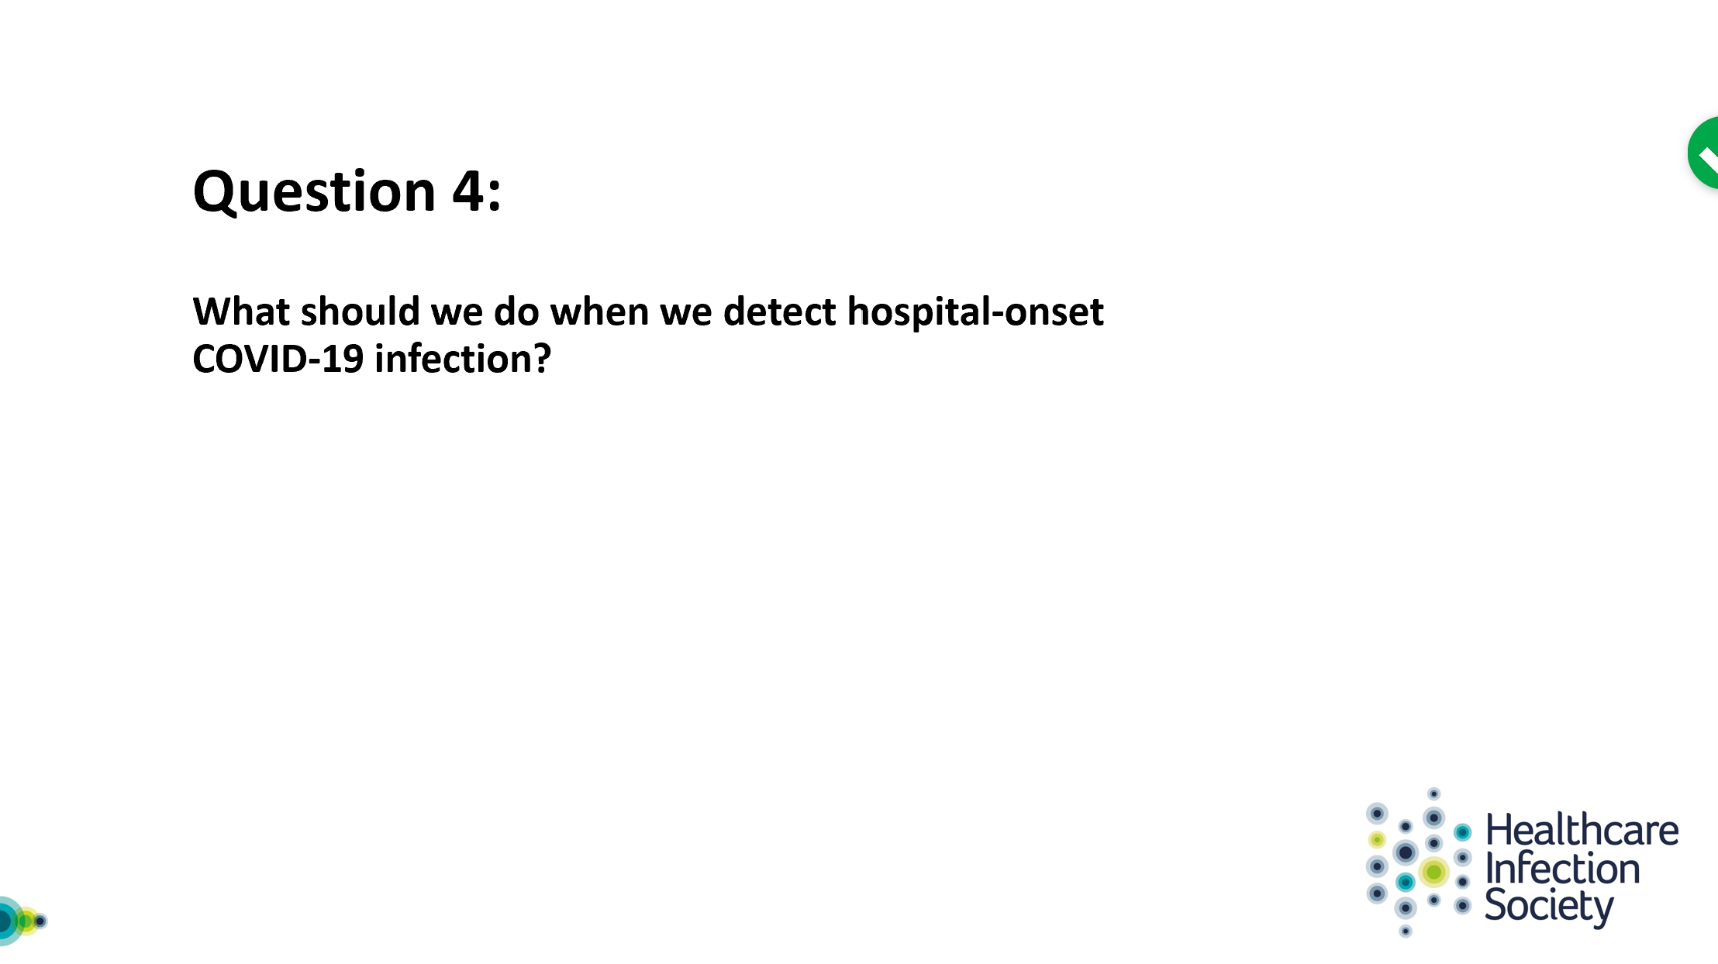
So, hopefully Eimear is going to be able to tell us exactly what to do in the next few minutes.

32:00 Eimear Brannigan
Thanks very much. What I’ve really missed in this pandemic is, you know, the book on the shelf that has all the answers. That's what I really missed during this pandemic.
And so I think we've heard a little bit about what hospital onset COVID infection might be, and we've heard a range. We've heard, it's probably beyond 14 days but it might be that some cases, earlier, are possible COVID infections. And the point of these is to prompt, looking a bit closer at what can be done to prevent onward transmission. So I suppose we need to think about what is the interpretation of detecting somebody in the hospital and does that mean that somebody who's come in incubating it that hasn't been recognized, or have they acquired a while in the organization. And I suppose, when we detect any healthcare associated infection it's an opportunity to go and investigate some details about the patient, of course, and the environment in which they are at the time that they have been tested positive. The pathway that they followed to get to that point, and what exposures they may have had along the way. And to think about how to best manage the environment. There's obviously something about managing the patient themselves who may or may not be symptomatic about point. And then, aiming to segregate them from other patients, and in a way that's suitable to the organization be that in a side room, and be that in a different part of the organization where there are risk managed patients, and maybe cohort them together. And then there's obviously, as Lisa's just alluded to, the bundle of IC interventions. Isolation of the patients….
<poor reception>

34:13 James Price
I'm sorry, things have gone a little bit crackly on the line. Again, the kinds of technical issues that we deal with on a daily basis.

34:25 Eimear Brannigan
Okay, can you hear me? Yes, fantastic I'll keep talking them I know you can't see me. So, obviously, it's an opportunity to promote hand hygiene among the patients in the area but also in the staff to the area.
<poor reception>
If we think, for example that it might be that staff have acquired or have been the source of acquisition for that individual, and therefore might have been working outside of that multi occupancy bay. And if we think about the mode of transmission being contact, and droplet by and large. And so, those thoughts trigger a lot of questions for me and for us we've discussed them a lot, and certainly locally as to how we might achieve some of these things. I think we should be aspiring to contact tracing and tracking the people around that person who, who has been detected perhaps unexpectedly, along the pathway that they are. So I’ll leave it there, and see what other people and have to say on the topic.

35:46 James Price
Thanks Eimear. So, I’ll just open it up briefly to the other panel members we've got maybe a minute, to see if any other comments.

33:56 Walter Zingg
Well, I mean, early on in the outbreak we had the hopes that once we identify a healthcare associated COVID patient that we could apply what we usually apply. You isolate, you do screening maybe around, and then that's it. But what we learned along the way is that actually once you have one case, this can really be the tip of the iceberg. And due to the longer incubation periods, compared to, to other upper respiratory tract infections, for instance, encouraged us to be a bit more, more aggressive. So by the end when we did it actually that is that once you have a healthcare associated infection, first of all, you stop admissions. And then you really screen for all the patients, if you find other cases - depends a little bit as there we were not always coherent practice -sometimes we did it sometimes we did not.
It's difficult to say when why we did it some cases but not in others. It depends a little bit on the experience we had actually with the different sites. I'll come back to that later when I talk about our experiences but, I think the bottom line here is to have a bit more of an aggressive approach to put everybody else in isolation precautions, with the patient in the room. Not in droplet precautions but at least in contact precautions, unless they have respiratory symptoms. And, and keep them actually in the isolation precautions for 10 days. Ten days was our timeline, not 14 days but 10 days where we were more confident to manage the situation - and actually this proved quite manageable.

Unknown Speaker 39:05
38:04 James Price
Thank you Walter. Let’s move on to question 5 now.

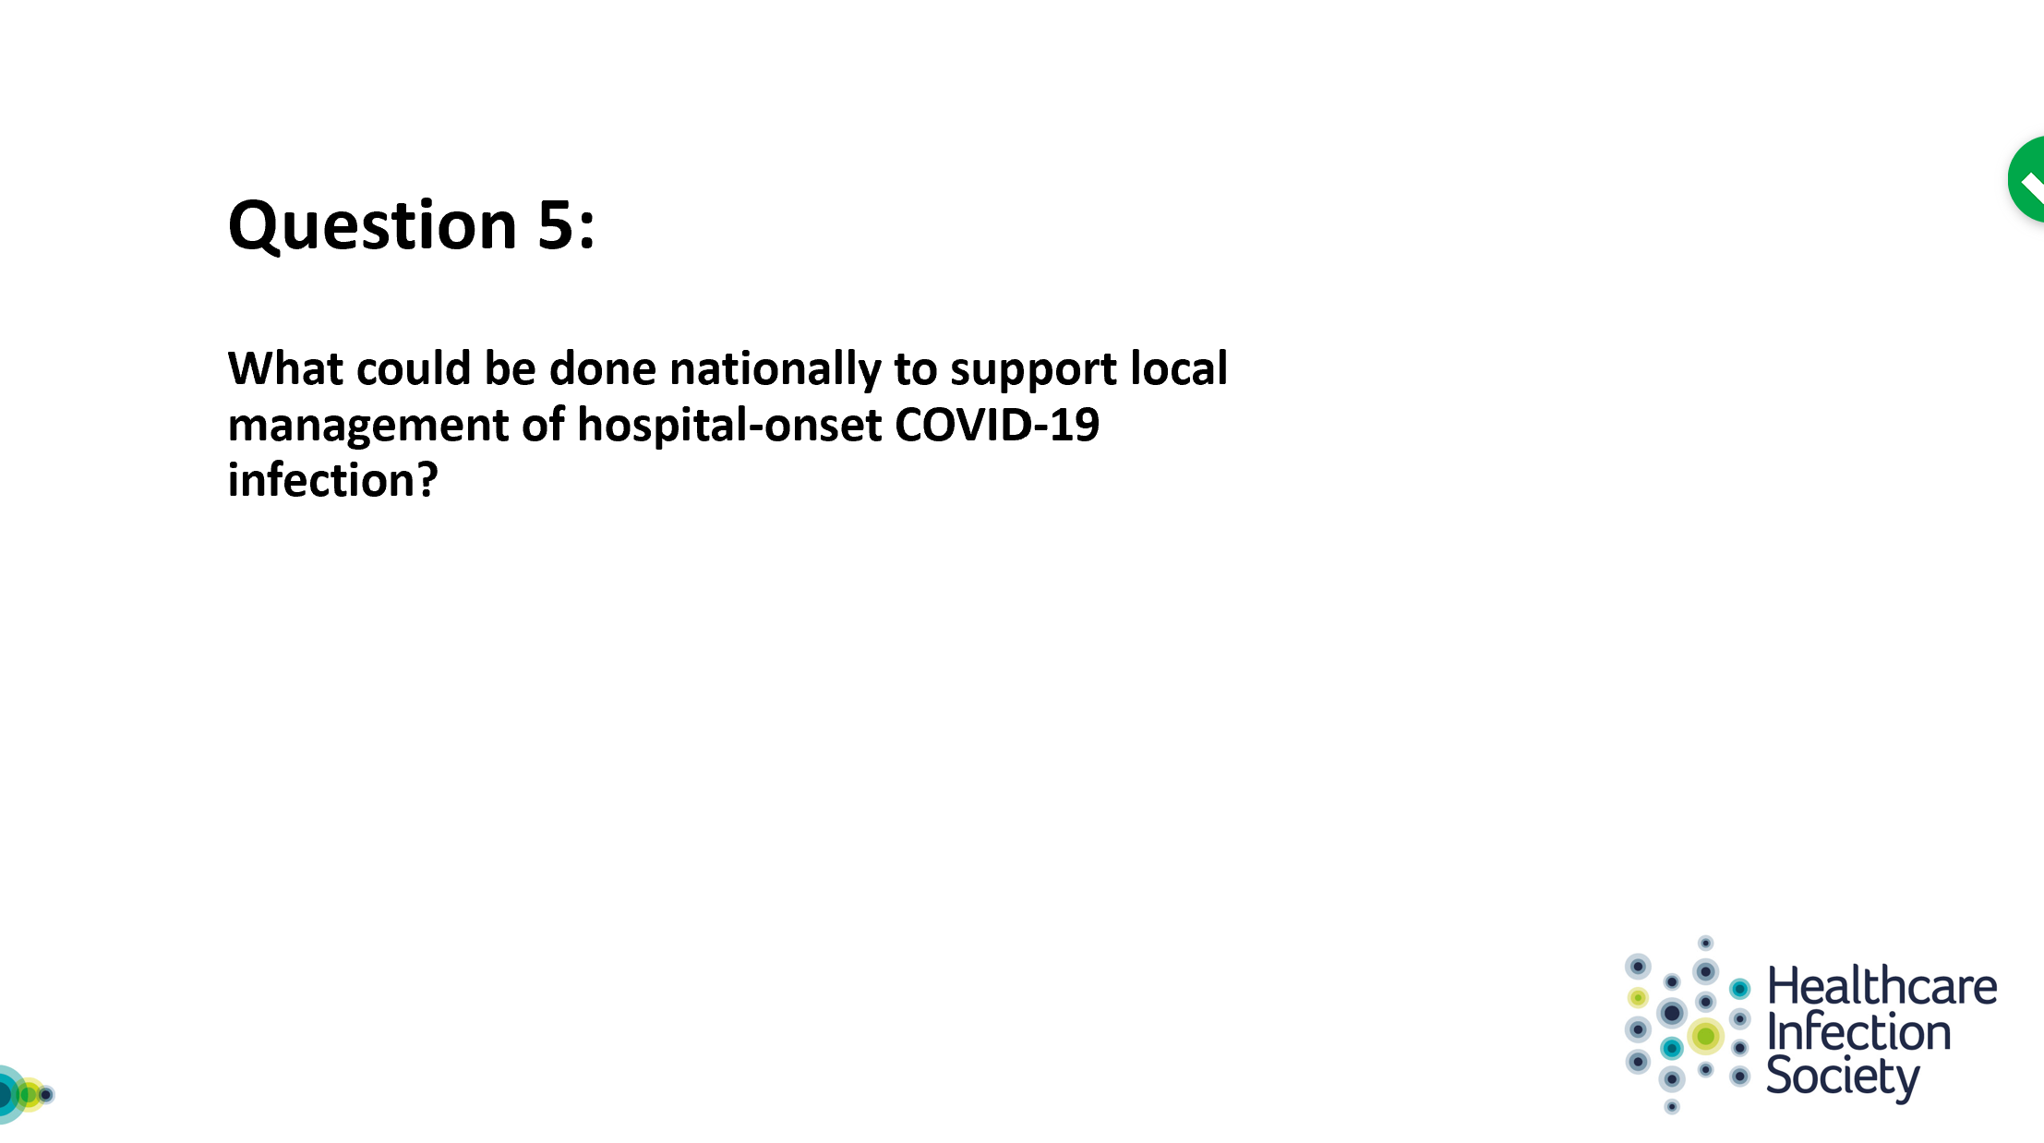
I’m going to ask Alison Holmes to give her thoughts on this please

38:20 Alison Holmes
I’m going to stick to the issue about the need for surveillance, but recognising all that Lisa has said about how there is national support to completely redesign, or crowded healthcare and think about ways we can deliver that in our challenged environments. So sticking with the surveillance. I think we need to think about this in terms of the identifying these cases are going to be critical for recovery within our acute health care, and there needs to be local support for people to be able to do this intelligently, and with end user engagement and recognize that clusters, or new cases can generate clusters that could propagate the persistence of the pandemic in our local communities. So I think it's really important that we frame that this is going to be an important phase, and that there might be a really, really long tail to this. And whilst in the of hot phase as Walter said we may not be, we may not have been able to do some of this. We certainly need to plan to do this in our, in our recovery and I think there needs to be support for that.
I also would like to see that there was encouragement of surveillance that was across patient pathways, across the whole healthcare economy, or across specialists networks because it's ridiculous to do it, just within acute healthcare without something a little bit more joined up. Pathways are likely to become more and more complex. We need to think about our renal dialysis patients, for instance, and other complex pathways and link it up, along with care homes and long term care facilities as well. So, a joined up approach would be brilliant. The capacity for testing will be ramped up and ramped up, and we need to use that to make our healthcare, as safe as possible. I think when we talk about capacity, we're only talking laboratory capacity. I think we're integrating healthcare testing in here, and I just want to flag that we really need support for Occupational Health within our Trusts, and that's another part of capacity that I really think it's critical. And we need to see as much support for that as possible. There are complex issues about managing staff as well even. Eimear mentioned track and tracing so you know in the UK, so much about tracking tracing and what will be done within the community. But what does track and tracing mean within health care, and how do we do that well maybe if we had an infrastructure of a lot of testing that could be much easier but I think we need to think about what track and tracing mean and working with the community and PHE on that will be really important, and important to get support for that.
And lastly, as, as Lisa mentioned, we need to be talking about winter planning, and we need to be talking about it now, how are we going to manage respiratory tract infections? How are we going to integrate that with our COVID management? And how can we maintain sensible pragmatic surveillance, and for a good while?

42:01 James Price
Thank you, Alison. I'm going to move us on in the interest of time to our next question.
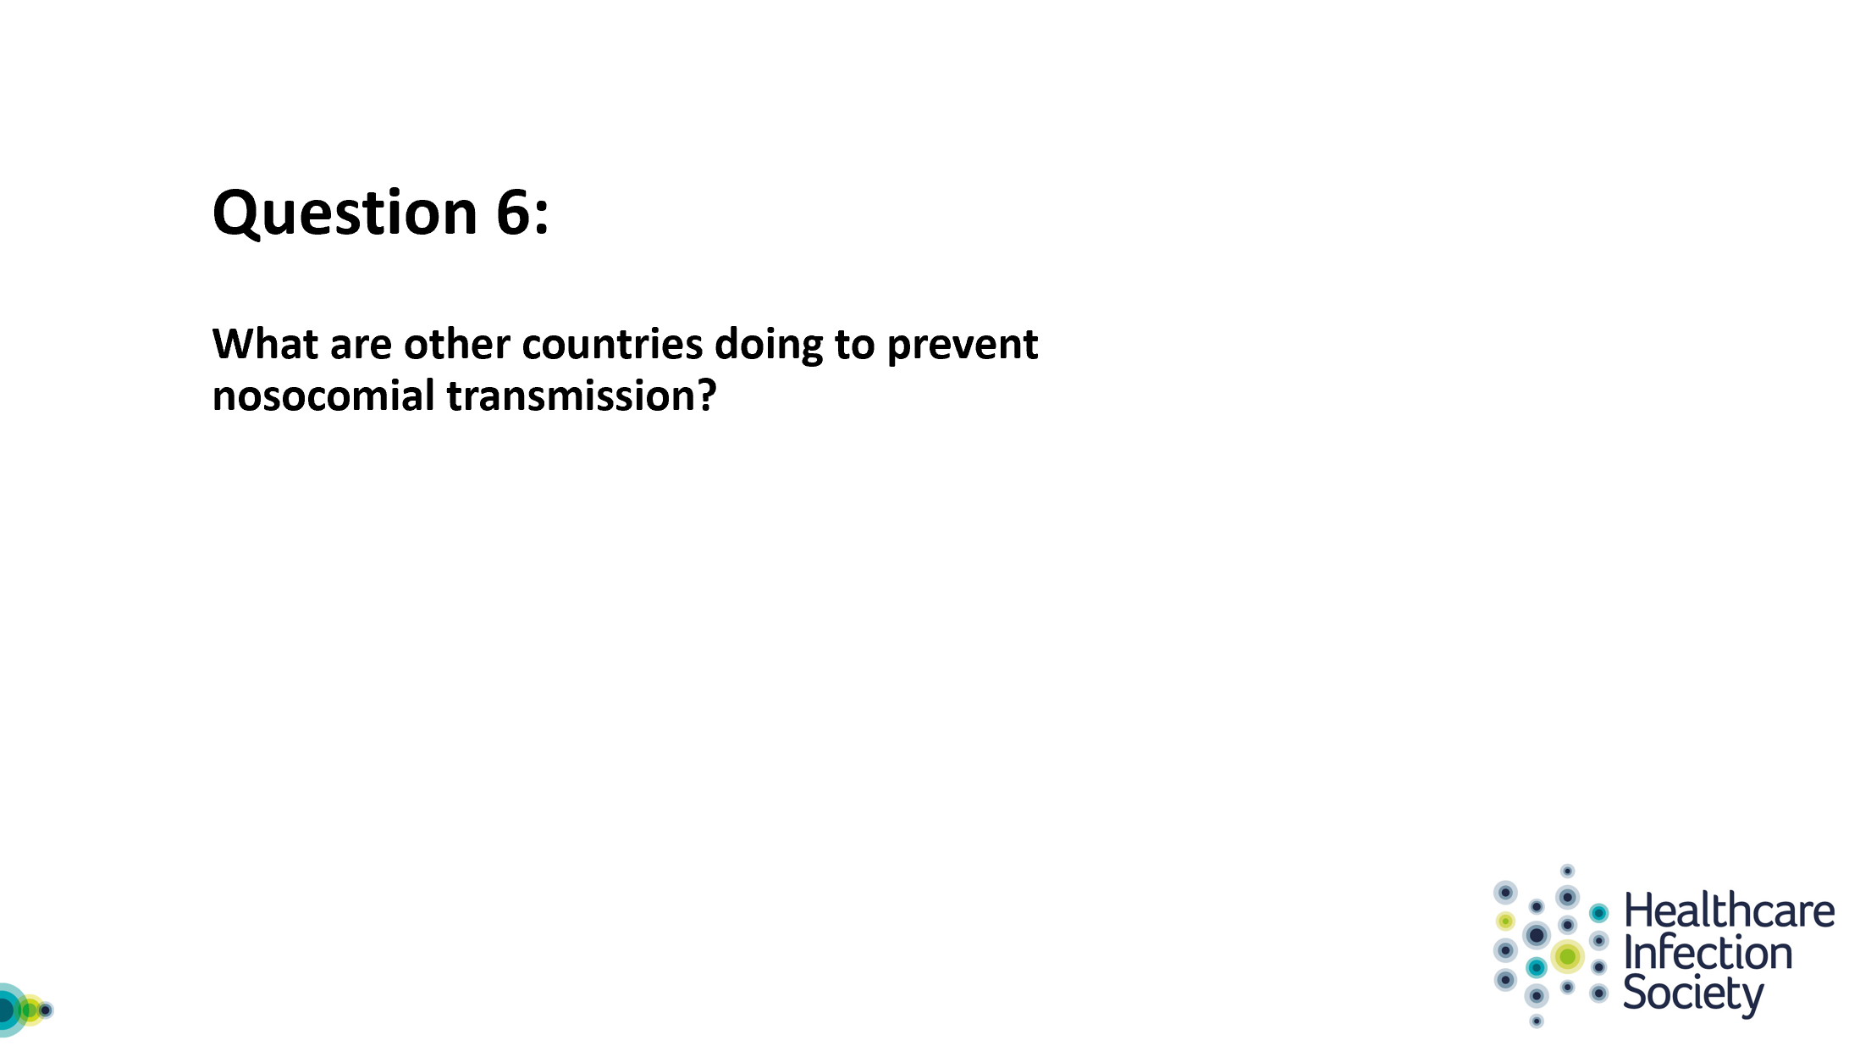

I'm going to move over to Walter to provide his thoughts on this piece.

42:20 Walter Zingg
Thank you. I will not provide the rest of the world but only I can talk about our experiences here in Geneva, Switzerland. As you as you may know that Switzerland was relatively early hit by the pandemic and relatively hard as well so we had quite a rapid increase of cases early on. And Geneva among different geographical areas of Switzerland was extremely hard hit as well.
Luckily, our hospital did quite anticipate the situation, and prepared the hospital to deal with the expected number of COVID patients quite well actually. Just to give you an idea when I talk about University Hospitals of Geneva, it's basically, it's eight sites, it's a main site with around thousand beds (internal medicine, surgery, ICU). There is gynecology, obstetrics and pediatrics basically on that site and then we have different sites, often, rehabilitation, geriatrics, long-term care, end of life care. And what the hospital did actually in anticipation of the COVID outbreak was empty basically the main building. We had, we prepared capacities up to 900 patients. We ramped up the capacity in the ICU from 30 places to 110 places. And basically it was really, it was important because, at the height of the outbreak we had almost 600 confirmed or suspected COVID patients at the same time hospitalized in the main building and more than 70 ventilated patients, COVID patients. So it was quite a difficult to manage. But actually we achieved to have nevertheless, quite a smooth management of the situation. What happened then is that the transmission then unsurprisingly occurred, not at the main site, but in the other sites: the sites that actually were initially meant not to have COVID patients, but then, all of a sudden had COVID patients and then, because we have so many sites, we had to deal with the fact that we could not remain some of the sites COVID negative. So what happened then is that we still had some sites, they remained COVID negative, but we decided to have COVID wards in otherwise COVID negative clinics or hospitals. And this is actually where the challenge was. Even when it comes to transmission from patients to health care workers we did not have too many transmissions in the late phase where we had COVID patients, but we had more transmission in mixed areas where we had COVID wards and COVID positive and COVID negative wards.

And we had a lot of transmission, we had a lot of health care workers affected early in the outbreak. Why is that? Geneva geographically, is more or less at the end of Switzerland. It shares a longer line, longer borderline, with France than it does with Switzerland. And many health care workers actually are pass the border to work in Geneva. They live in France and they pass the border. So what happened early on in the outbreak is when we, the government declared confinement, and the borders were closed it became all of a sudden very difficult for health care workers to cross the border. So they had to wait hours until other solutions were found, which were actually there were, finally there were borders. I mean health care workers they get some badges to cross more rapidly the borders. There were borders reserved only for health care workers, basically, so that they could pass a border rapidly. But the problem is that there was a lot of car sharing and healthcare workers they did not even leave Switzerland, but they rented apartments and shared the apartments. And we know at least from some of the sites that this is where transmission actually occurred in the early phase.

And another problem we had, bringing back to the question of distancing, is that also we had a problem with main areas, shared areas, restaurants, where it took us quite a while actually to just physically indicate where you can and where you cannot sit so to maintain physical distance. And then, what was a very bright idea that due to some donations for during the entire outbreak food was for free for health care workers, which is nice. But on the other hand, this brought many health, more than usual, health care workers to the restaurants. Actually they served, I think, three times more dishes per day as they would serve normally. And you can say this is, I mean those are when you go to the details of, there are many, many details that contributed to the transmission between health care workers. So our main concern, became actually that health care workers got infected by peers, because they did work gatherings, they did not maintain the physical distancing, they met in the in joint rooms, in the restaurants.

Despite having universal masking quite early on in our outbreak, actually, but this was, the problem is that in one area for instance, and one clinic that remained COVID negative until the end, we had a very early outbreak, first in health care workers and then in patients. And this really went hand in hand, and we knew that most of the health care workers actually got infected just before we started with universal masking and we, you established all the more rigorous measures in the hospitals. But the damage then was done. It took us almost two to three weeks until it was actually stamped out. And half of the patients and half of the health care workers in one particular ward of this clinic were just became infected.

As I mentioned before, to avoid transmission, we keep always the same message: keep distancing, if you can; if you cannot keep distancing wear a mask. And do hand hygiene. So this is this is really the mantra, we tell everybody. And when we, but sometimes when we attend meetings, we see that not everybody is wearing a mask despite that physical distancing cannot be maintained.

I already mentioned that once we had patients, we put the neighboring, we put the patients in the same room in contact precaution measures. If they became symptomatic respiratory tract with, we ramped up to droplet precaution measures, we stopped admissions. Our timeline was 10 days, admissions stop until since the last positive case. And also isolation precaution measures in the same room for 10 days after last case in the room. And this actually proved quite efficient, I have to say, because health care associated COVID infections really dropped dramatically towards the end of the outbreak, also because the overall burden of course didn’t, decreased. But I think the key message I, or the lesson I learned during that time was really, we have to focus a lot on how health care workers meet, the behavior of health care workers among themselves. We, our concern was more that health care workers brought infection to patients than patients actually infected healthcare workers. And, yeah, so this was probably the main lesson learned and also that the major problem is mixed sites where you have COVID, a unit, COVID positive wards and COVID negative wards, and still health care workers they meet at some place, you cannot totally detach physically, physical spacing.

52:00 James Price
Walter, thank you. Fascinating.
Due to the suboptimal chairing, we're now running towards six o'clock. I'm going to suggest that we move on to our live questions because we've had some really fascinating questions coming through, that Richard has been working very hard in the background to collate.
I'm going to suggest that we spend a few minutes on these. I appreciate we are meant to finish at six, but if people are willing to hang on for a couple of minutes afterwards. I think it's been great and we really needed to hear what the panellists had to say, but it would be great to answer some of the audience's questions.
So, let's move on to the first question
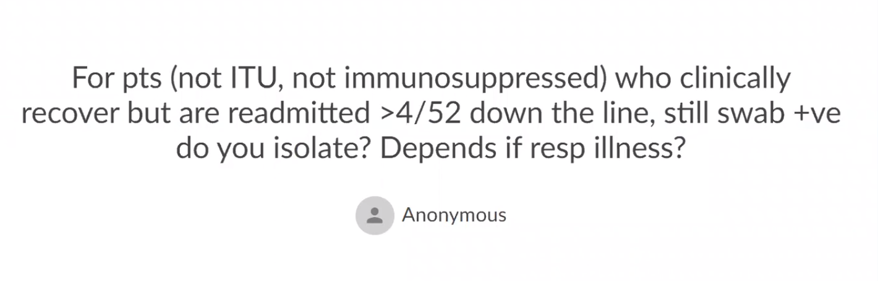
A straightforward question. Would any of our panel members like to comment on that?

52:58 Eimear Brannigan
I'm happy to have a go, we've, we've evolved this, I think, as time has moved on. I think, at the start we kind of very much stuck with, you know, if you're readmitted and it's 14 days since, since your symptom onset, then we'd all be very comfortable. And then we realized actually we weren't all perhaps as quite as comfortable because in fact these people were being retested. And of course then when you think about - in this particular question it asks about post - ICU - trying to understand when you, you know, start to consider somebody less risk of infection. That is tricky for everybody to agree on, I suppose, and it's very easy to give the advice, but is it advice that everybody's going to buy into and support? I think that's where we find our challenges. I think four weeks down the line, if someone were readmitted and tested positive. Of course in the New World, they're going to be in a blue pathway anyway. And I would think we would probably now consider them as a low risk, but I think it's very difficult to say zero risk, especially when people aren't comfortable with it. I think though we're increasingly seeing data that cultivable virus or viable virus, isn't present at that time frame.

54:06 Alison Holmes
I'd like to echo what Eimear said and just like to say that that was, it's really reassuring to get that data on in terms of that you know four weeks down the line, they may be positive terms of RNA but it's not viable virus.

54:29 Walter Zingg
And, yeah, I mean we also follow rather pragmatic approach in many ways what when is a COVID positive patient considered not infectious anymore? We had to come up with something to manage clinical practice on a daily basis. So, if a patient has no symptoms 48 hours after similar not having symptoms and at least 10 days, we consider. Okay, fine. Then we have two patients after three weeks after symptom onset. It's really, usually we would also consider negative without even doing a test, then of course we have two patients within the two there, we recommend in to do a test. If theremis still concerned that patient could be still infectious. But, I mean, this is a, they're always we are in medicine there will always be exceptions, we cannot cover 100% all situations and we have to, to, to have to live some manageable definitions.

55:42 James Price
Thank you, and Lisa was there anything you wanted to add?

55:48 Lisa Ritchie
Nothing further from what the panellists have already said. I think it is challenging. And I think also when we are heading into that other season and also remembering all the other pathogens that are out there and around our hospitals that people could get. It is challenging.

56:05 James Price
Thank you. Well, let's move on to our next audience question.

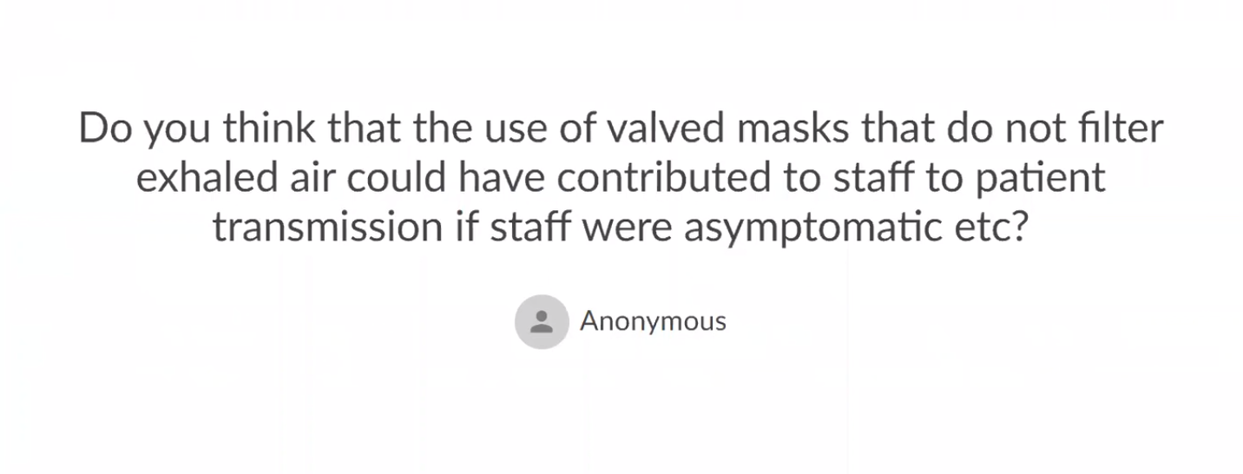
Please feel free - whoever would like to take that on.

56: 36 Walter Zingg
Well I mean what to say? This brings us to the totally everlasting question of when are you infectious? I mean we know we can be pre-symptomatic we can be asymptomatic. Basically we should not use those masks if we can avoid it. I mean this is the message here. And once we use them, I mean we have to live with the risk. I think this is as, as far as it goes.

57:00 James Price
Any other comments at all? Stunned silence, that's fine…

57:19 Alison Holmes
I just wanted to ask Walter, is there any use of visors in the Geneva Hospitals?

57:26 Walter Zingg
Yes, not on an official basis. Basically, the only official introduction we had with visors was in the step down – in the intermediate care unit for removing the canula of tracheostoma. So this is where we really understood that this is a messy procedure and needs a bit more than goggles.

57:58 Alison Holmes
No – I meant using visors instead of masks with staff.

58:02 Walter Zingg
No, no we don't. We say now, because we had so many visors being printed at home and brought to the hospitals, that finally we decided to use visors or goggles equally, but always with a mask.

58:20 Alison Holmes
Ok, thank you.

58:21 James Price
Right, thank you everyone. Shall we move on and have one final question from the audience?

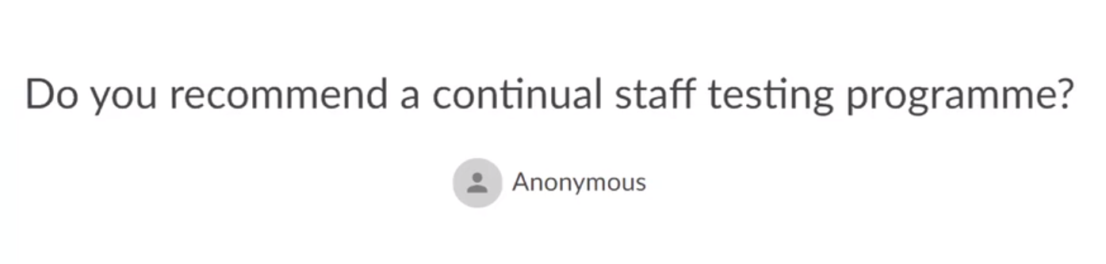

58:39 Alison Holmes
So, if there was no bottleneck in our laboratory’s capacity, and if the testing was acceptable – as testing methods are improving they don't need to be reaching up to brain tissue – I think we should be looking at that. But then, as I said, I think that we need some occupational health support as well. But I think as much staff testing as possible would be excellent. And I mean that across healthcare, so not just in acute care but also in residential care.

59:23 James Price
And Alison, is this all staff, is this clinically-facing staff…?

59:30 Alison Holmes
Ah, so that's a whole different set of really interesting questions, and it alludes to what Walter was saying about the level of staff-to-staff transmission, and also what's coming in from the community. So, yeah, very interesting.

I think we need more data on that, and I would make it as broad as possible. We need to think about all our staff, I think, particularly when they're sharing spaces and the social distancing that Lisa has described may not be in place for a little while. And we also need to recognize that we've got many, many key staff that are not just the clinically-facing ones but absolutely essential for clinical care and the management of patients. We need to include them certainly as well. But the issue about maybe considering administrative staff too is another issue.

1:00:33 Walter Zingg
I think we have to distinguish between staff testing when they are symptomatic and staff testing on a regular basis. Personally I totally agree that if staff are symptomatic they need to have the opportunity to get tested, I think there is no way around that. If we should test staff on a regular basis, I don't know. Alison?

1:00:58 Alison Holmes
I would support testing staff on as regular a basis as possible, and assuring ourselves that we're delivering safe care, and we're also looking after our staff simultaneously.

I mean, I think we should be aspirational as it does depend on testing capacity, but I hope that that will certainly improve.

1:01:21 Walter Zingg
It's interesting. I mean, after what we have seen and what I have said, actually the major problem is really infection among peers and from healthcare workers to patients. Yes, it's worth giving it thought.

1:01:38 James Price
Thank you, everyone.

1:01:40 Eimear Brannigan
Another point I was going to just add is that I think when we have done testing of asymptomatic staff, for example in a reactive way to detecting a cluster, the staff have really valued that and find it a really useful signal that the organization is responding to their needs. And so I think that that visibility of supporting the staff is an important part of it. It is not the only consideration of course, but it is a consideration. So I think, along with acceptability, is the notion that testing is a support thing for staff.

1:02:15 James Price
Fantastic. Thank you everybody. I think we can move on for the audience to our final poll of the day. Let's see if that comes up rapidly. Fantastic.
So this is a bit of feedback. We like to ask you ‘to what extent do you agree with the following statement: this webinar has been useful in clarifying some of the issues related to hospital onset COVID infection.’
And again, we're really interested. This is part of a series of webinars: we're interested to get people's feedback on how we can evolve and improve this to suit the audience's needs.
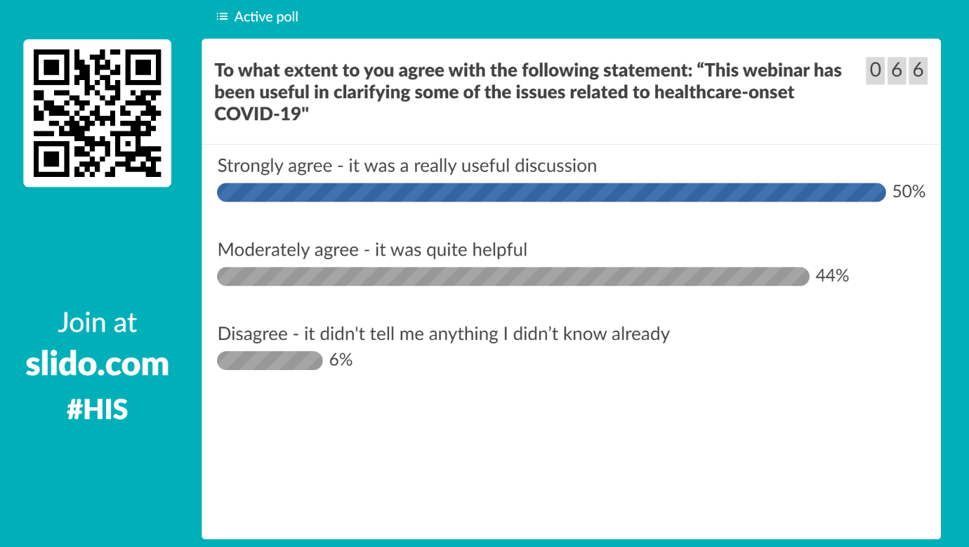
And so whilst we didn't hit the mark for some people, I think generally there's a positive noise which is fantastic.
I apologize for being five minutes over, but it leaves me to say a big thank you to our panel members, to Alison Holmes, to Walter Zingg, to Lisa Ritchie, and Eimear Brannigan. Again, to thank the Healthcare Infection Society for hosting this event, and to everyone in the audience for listening. Don't forget to tune in to our next webinar, the details are going to be coming out shortly. And I wish everyone a happy bank holiday.

